**Micro-Project (Part-1)**

*For partial fulfillment of Activity Based Learning*

*for Course*

**Data Communication & Networking (3028)**

**Network Design Task-01**



**Submitted By:**

**Arpita Srivastava (2104069)**

**Navanita Das (2104111)**

**Saurav Kr. Yadav (2104117)**

**Rashmita Biswal (2104118)**

**School of Electronics Engineering**

**Kalinga Institute of Industrial Technology (KIIT)**

**Deemed to be University, Bhubaneswar -751024**

**Aim :**

Design, configuration and simulation of heterogeneous network i.e. wired (**IEEE 802.3, ETHERNET**) and wireless (**IEEE 802.11, WLAN**) with two routers along with the use of **CISCO** networking devices for the analysis of traffic in network and other observations using **CISCO Packet Tracer**.

***Network Scenario :***

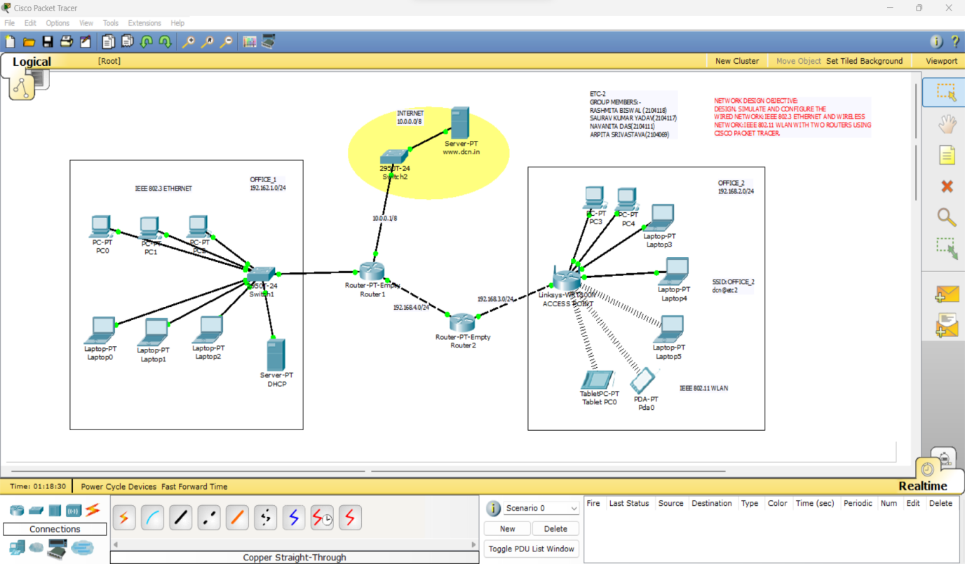

***Software used:***



**CISCO Packet Tracer**

***Network Specifications :***

* ***Heterogeneous Network***

***Table. 1***

|  |  |  |  |
| --- | --- | --- | --- |
| **Name** | **Network Address** | **IP Configurations** | **Gateway** |
| OFFICE_1 | 192.168.1.0/24 | 192.168.1.2/24 -  192.168.1.254/24 | **192.168.1.1/24** |
| OFFICE_2 | 192.168.2.0/24 | 192.168.2.2/24 -  192.168.2.254/24 | **192.168.2.1/24** |
| INTERNET | 10.0.0.0/8 | 10.0.0.2/8 -  10.255.255.254/8 | **10.0.0.1/8** |

* IP Configuration: **Dynamic Host Configuration Protocol (DHCP)**

**Note:** All are Class-C Networks default subnet mask: **255.255.255.0**

* ***Internet (Network Address : 10.0.0.0/8 )***

**Class-A Networks default subnet mask: 255.0.0.0**

HTTP(s) Server hosted on a Generic Server (End Device).

IP Address of Server machine 10.0.0.2 (e.g www.kiit.ac.in)

Default Gateway: 10.0.0.1

* ***Cable Specifications***
  + Connections > Copper Straight -Through

(Between PC/Laptop/Server to Switch and Switch to Routers)

* + Connections > Copper Cross – Over

(Between same device like Switch to Switch and Routers to Routers)

* ***Switch Specifications***
  + Type: CISCO 2950T-24 (Switch for Wired LAN)
  + IEEE 802.3 Fast Ethernet (FE-Copper)
  + Standard: 100-Base_TX
* ***Wireless Access Points / Routers***
  + - Type: Linksys-WRT300N
    - IEEE 802.11 standard - ISM Band 2.4 GHz
    - Authentication: WPA2-PSK
    - Encryption: AES
    - SSID: OFFICE_2 for respective office location
    - Pass Phrase: dcn@etc2
    - LAN: IP Configuration: DHCP as per ***Table.1***
* ***Router Specifications***
  + Type: Generic (Router-PT-Empty)
  + Add Hardware interfaces: Fast Ethernet 100 Mbps
  + Network Interface Card (NIC) – Network Adaptor : IEEE 802.3 Fast Ethernet (FE-Copper)
  + Standard: 100-Base_TX
  + 3 NICs for Router 1 (R1)
  + 2 NICs for Router 2 (R2)
  + Routing Protocol: Routing Information Protocol v.1 (RIP v1)

**Intermediate Network Specifications :**

|  |  |  |
| --- | --- | --- |
| **Between Routers** | **Network Address** | **IP Address of Gateways** |
| AP (OFFICE_2) – R2 | 192.168.3.0/24 | 192.168.3.1 & 192.168.3.2 |
| R1- R2 | 192.168.4.0/24 | 192.168.4.1 & 192.168.4.2 |

**NB: AP Access Point (Linksys-WRT300N)**

**PC/ Laptop/ Server Specifications :**

* + End Devices > Generic PC/laptop/Server

**Procedure:**

As per the Network scenario diagram given above, the required networking devices like Wireless Access Points, Routers, Switches, PCs, Laptops, Wireless Tablets and Smart devices (PDA) were placed. The required cable connections were made. All devices were configured as per the specifications given above. Some of the device configuration methods (Screenshots) are given below:

***Basic Configuration***

# *Wireless Access Point Configuration (Linksys-WRT300N) Config > Wireless*

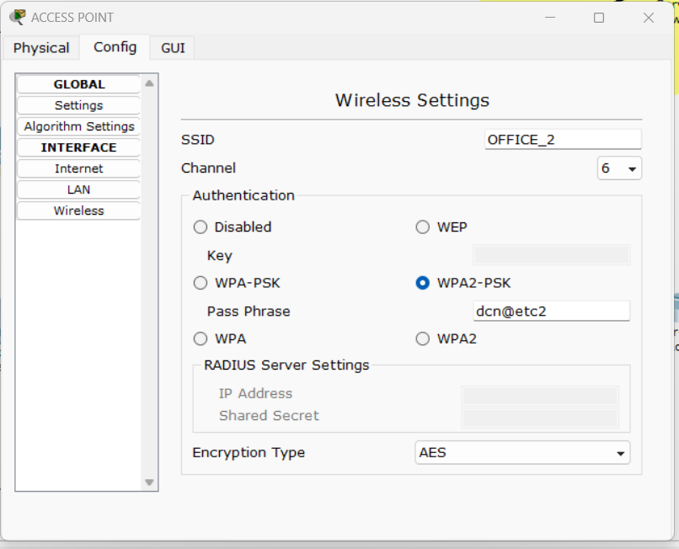

***Config > Internet***

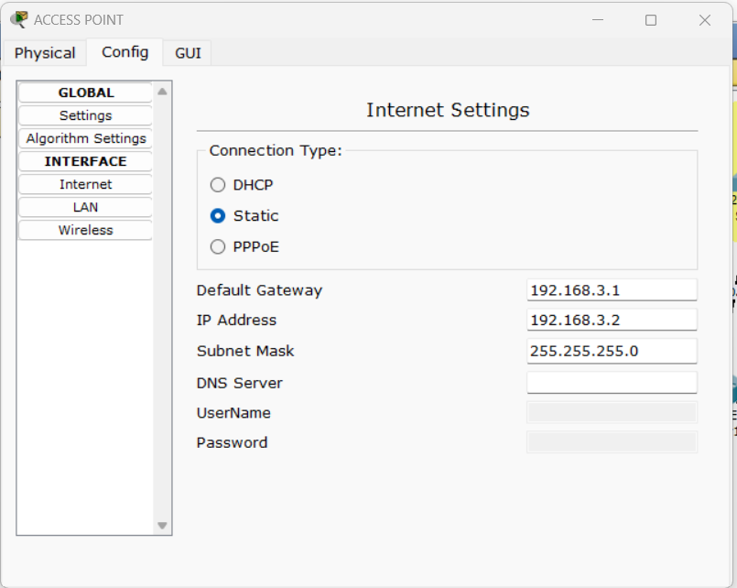

***GUI (LAN→ DHCP Configuration)***

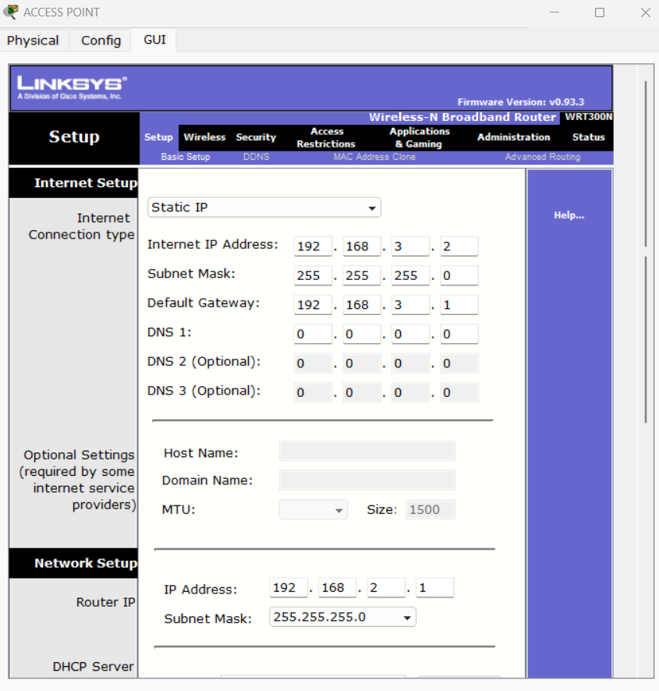

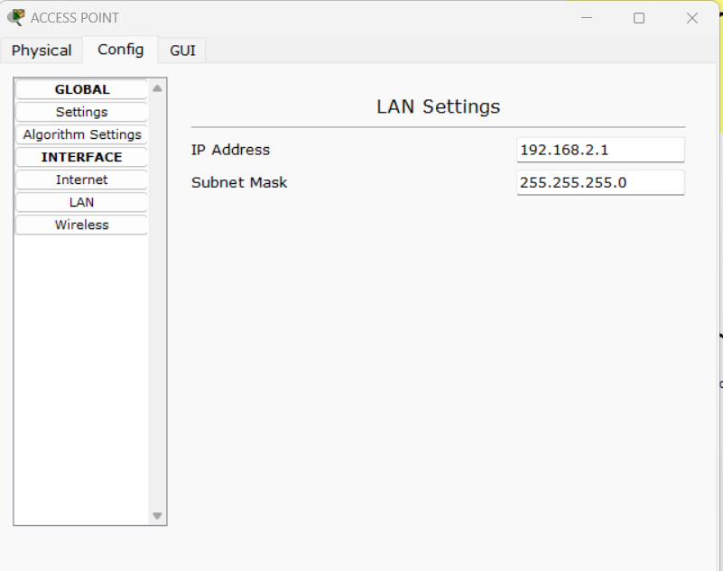

***Then, Save Settings.***

1. ***Laptop***

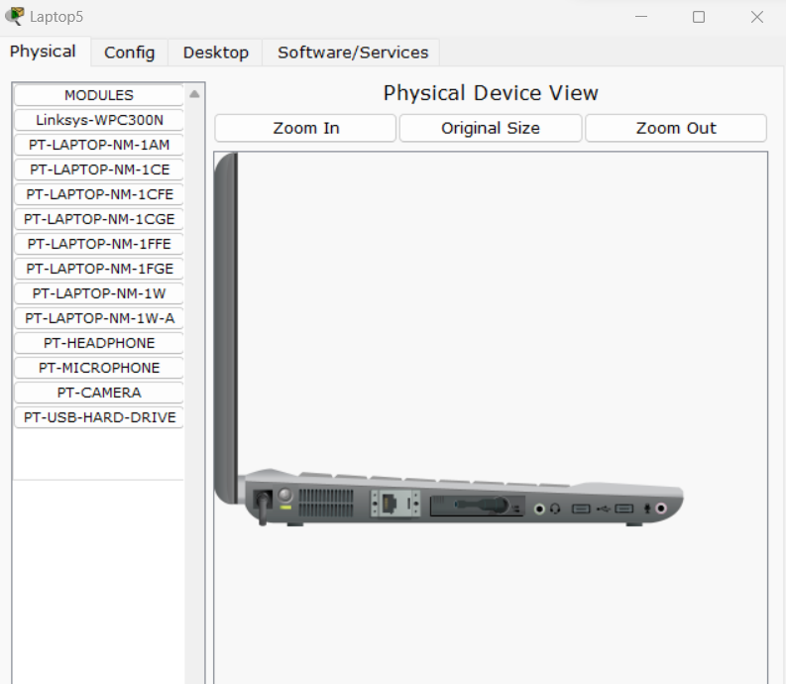

***“Linksys-WPC300N” module is inserted into laptop and then it is switched on.***

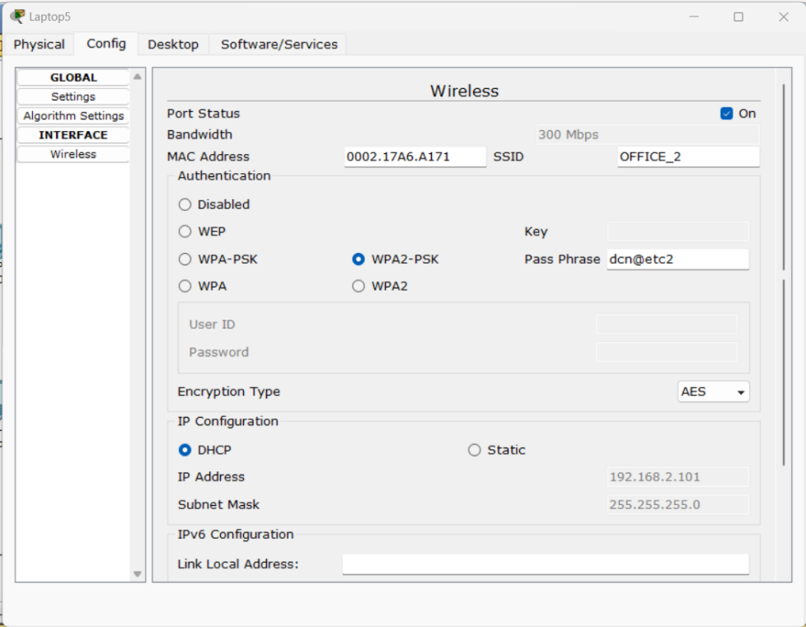

***Config > laptop***

1. ***Wireless Tablet/ Smart device (PDA)***

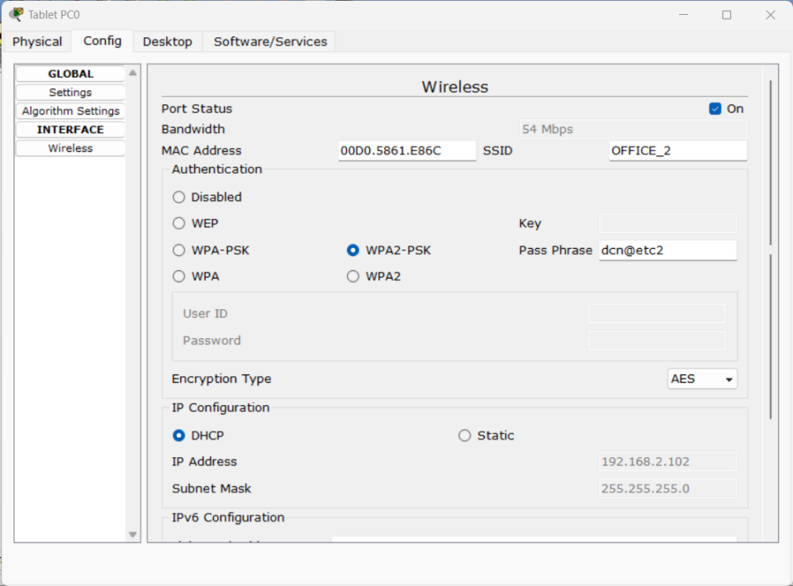

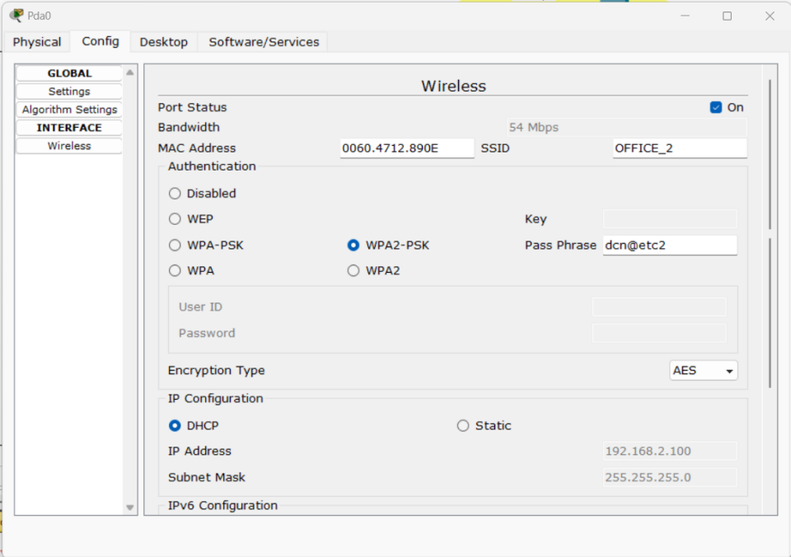

1. ***Other wired end devices***

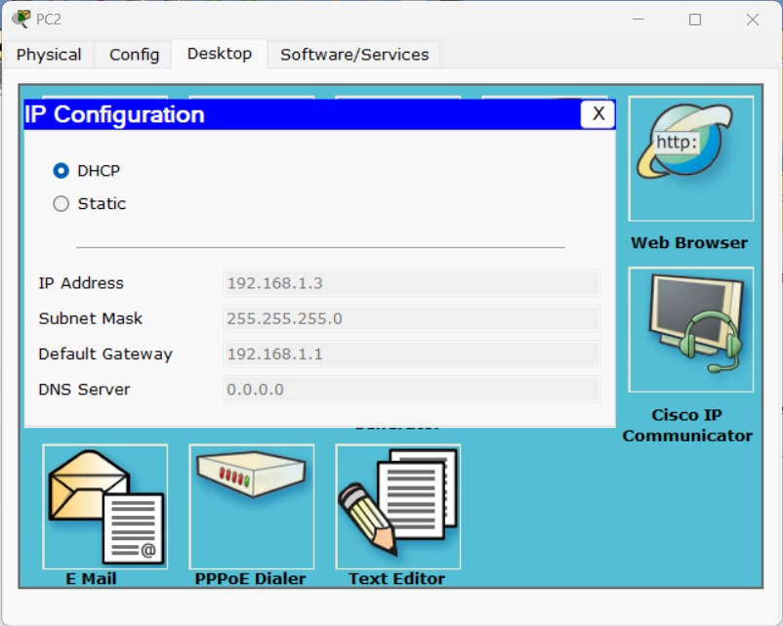

***All PC connected to wired Ethernet Network must be configured as***

***Desktop > IP Configuration > DHCP.***

1. ***DHCP Server***

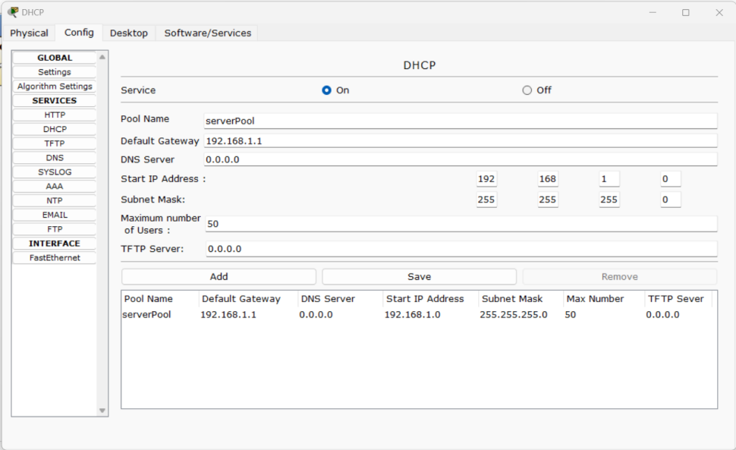

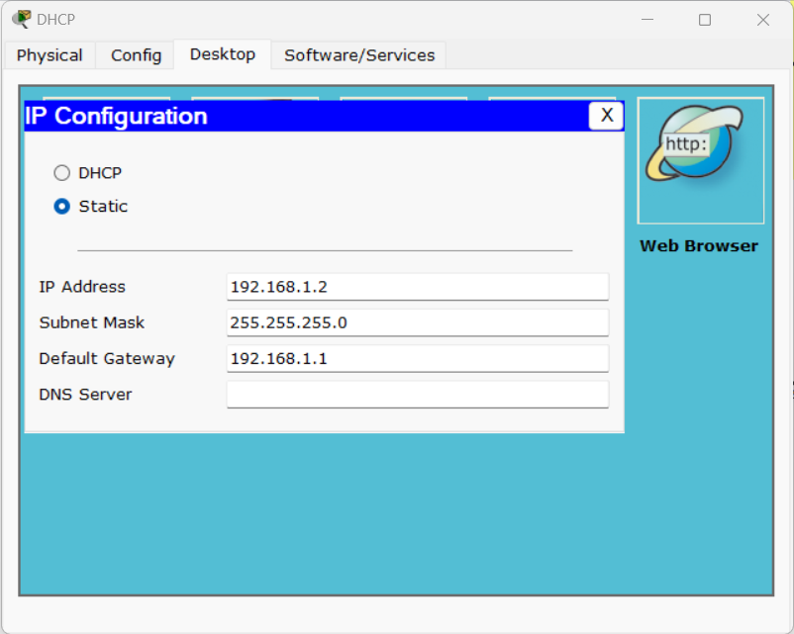

1. ***Router***

* Place ***Generic Routers*** from the **Router Menu** from the **Lower left corner of the window**.
* **Double-Click** on **Router** to open **Menu**. In **PHYSICAL TAB**.Add a extra **PT-ROUTER NM-1CFE interface**by dragging and dropping at the back panel of the Router.
* Similar to placement of Router, place **CISCO Catalyst 2950T-24 Switches** and End devices like PC and Server as required.
* Connect **Copper Straight Cable** between **PC-SWITCH, SWITCH-ROUTER**.
* Connect Copper Cross Cable between **ROUTER-ROUTER** and **SWITCH-SWICTH** interfaces. Give the suitable IP Address in Router interface by refer by double clicking on **ROUTER > COFIG > Select the suitable interface> Give the IP Address** in the Space given.

***The above mentioned steps are shown in the figures below:***

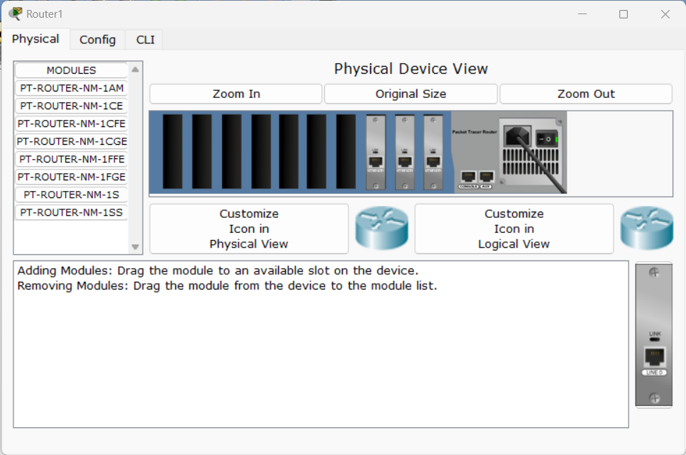

**R1**

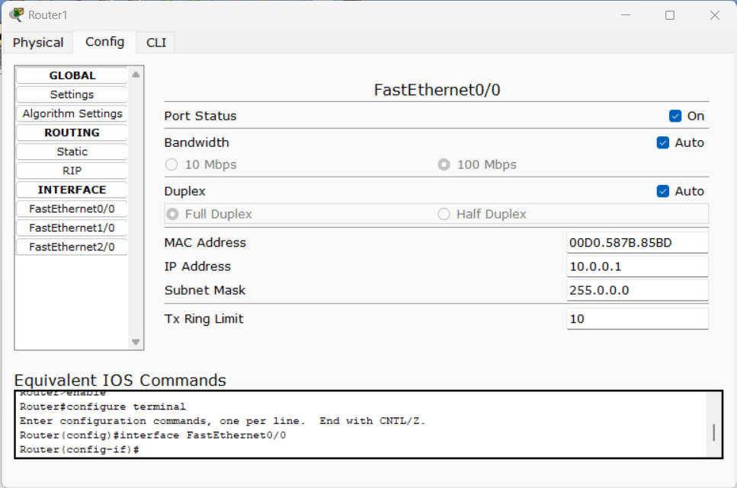

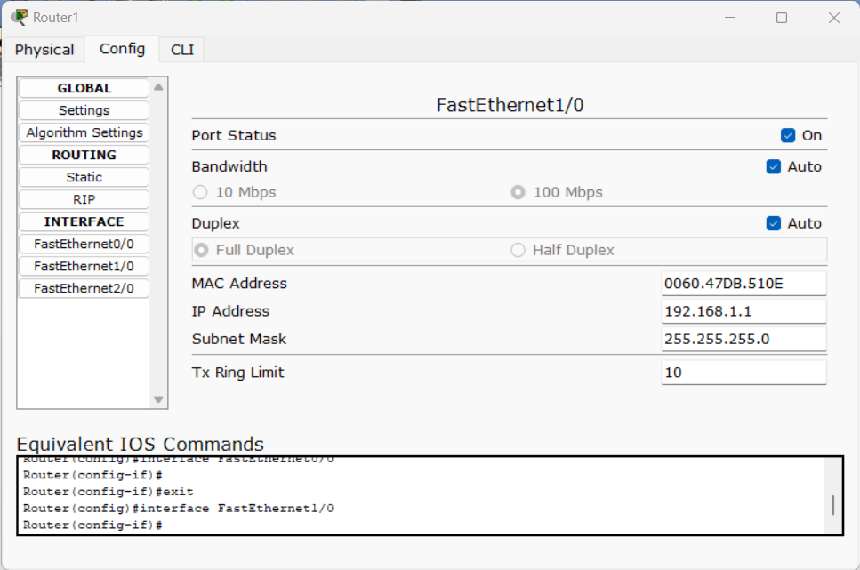

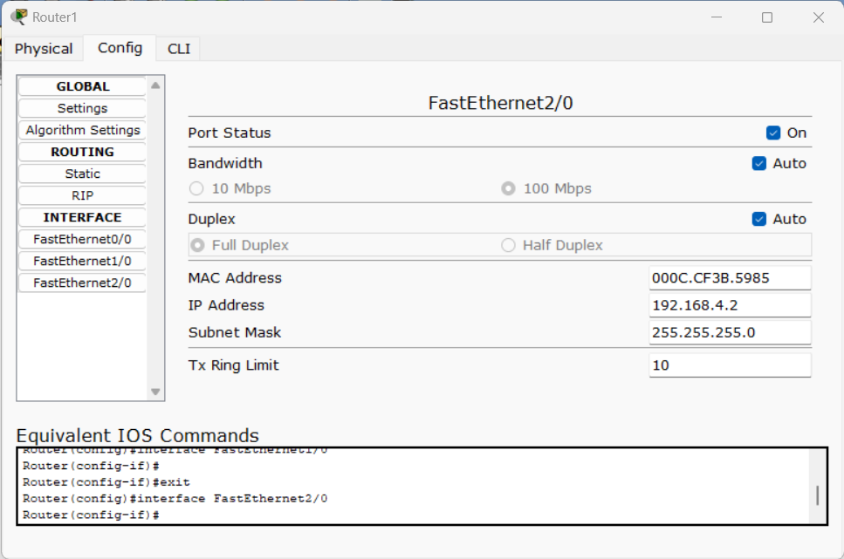

**---------------------------------------------------------------------------**

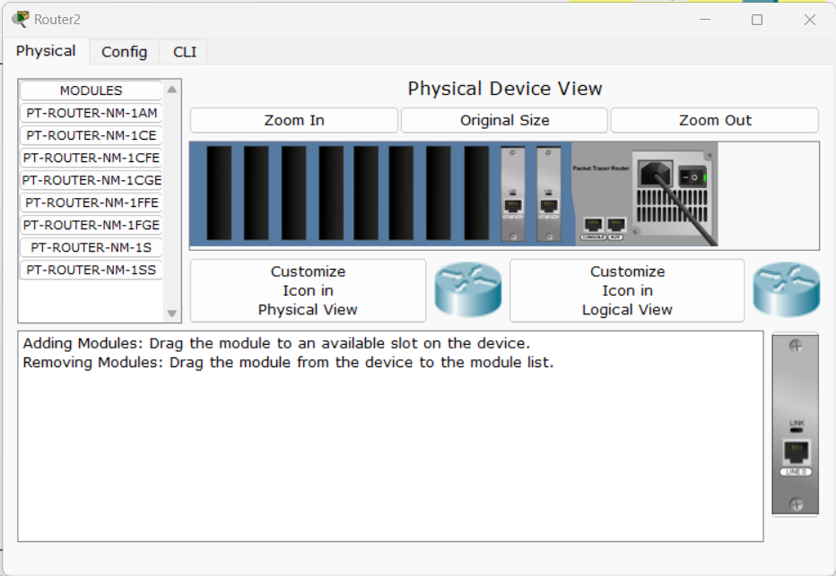

**R2**

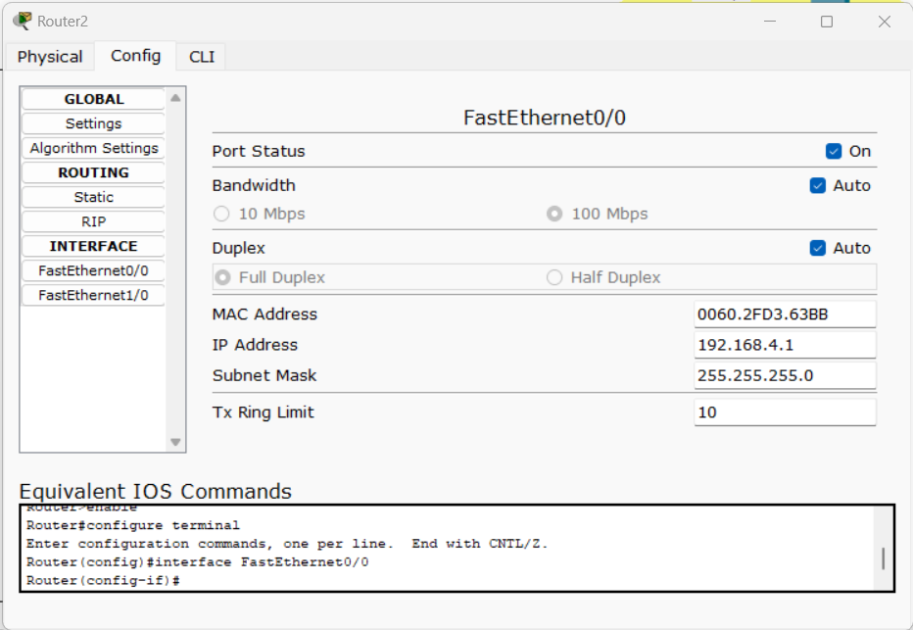

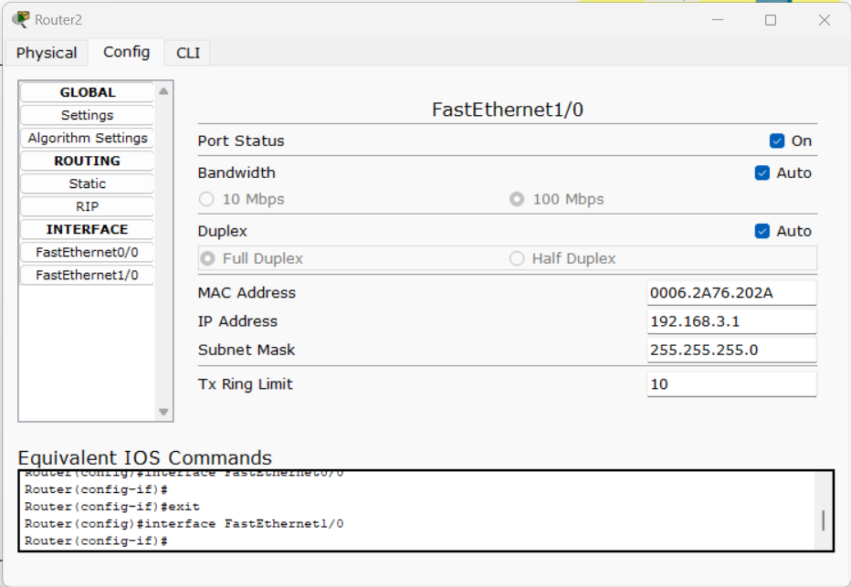

1. ***Routing Protocol: RIPv1***

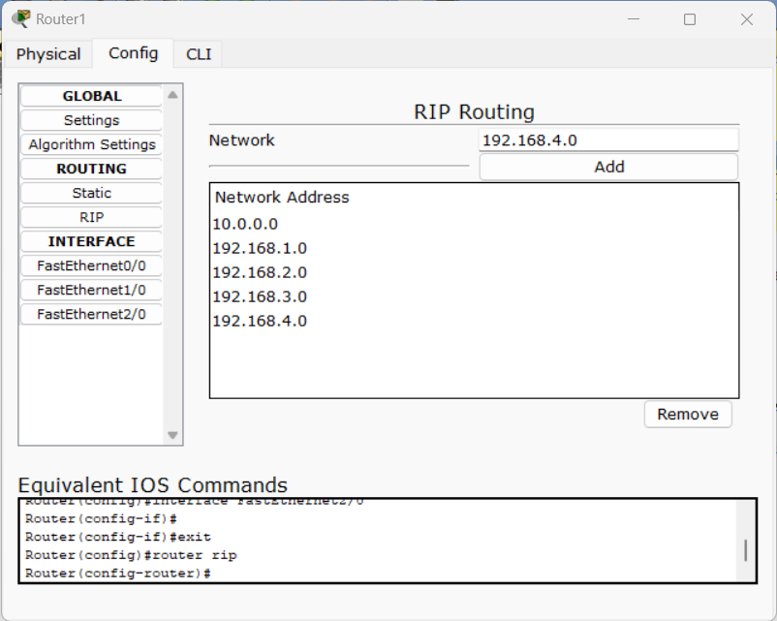

1. ***HTTP Server***

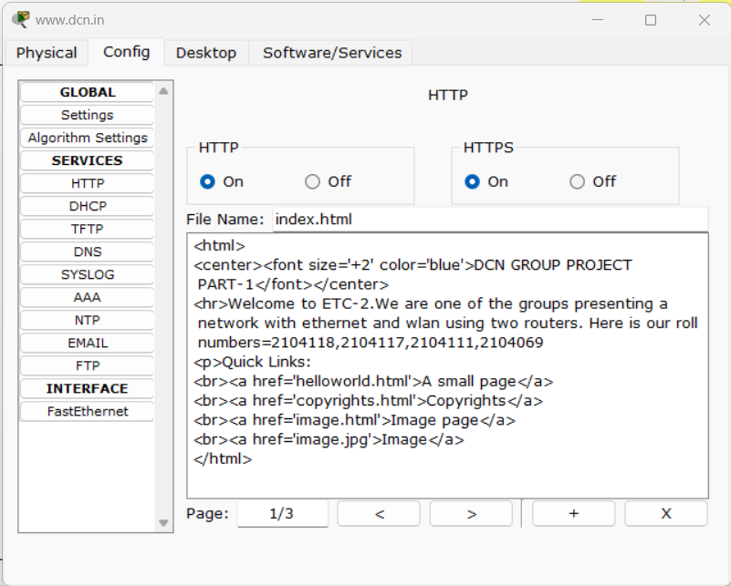

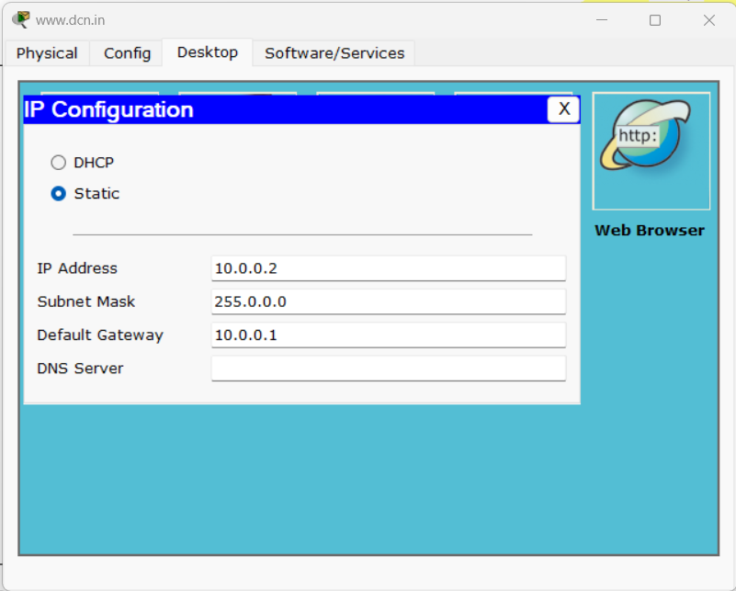

**Observations:**

***After designing and configuring the complete network, followings can verified and observered:***

* ***Wireless devices getting associated with the Assess Point using Radio Links.***

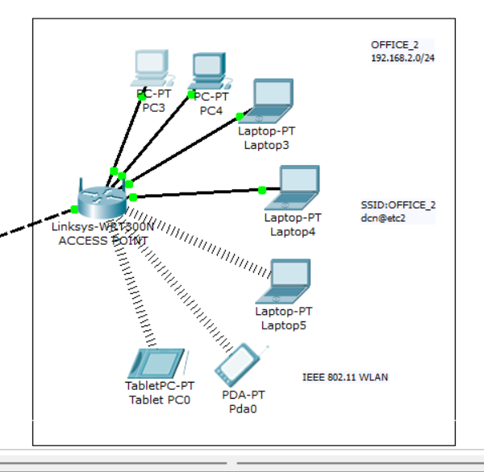

* ***DHCP messages for automatic assignment of IP Configuration.***

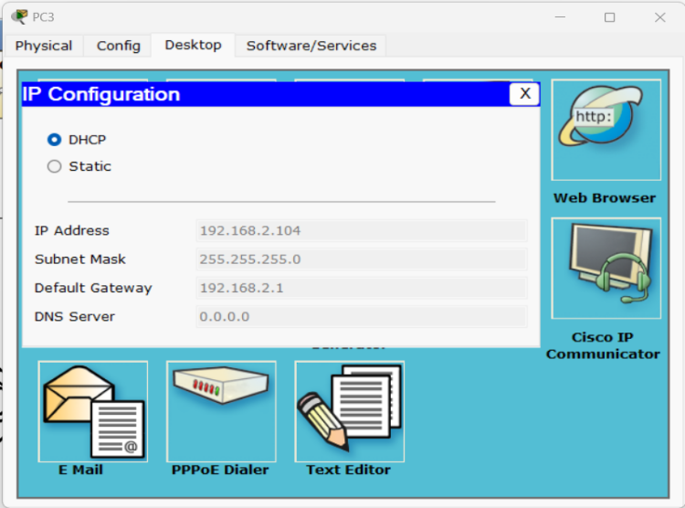

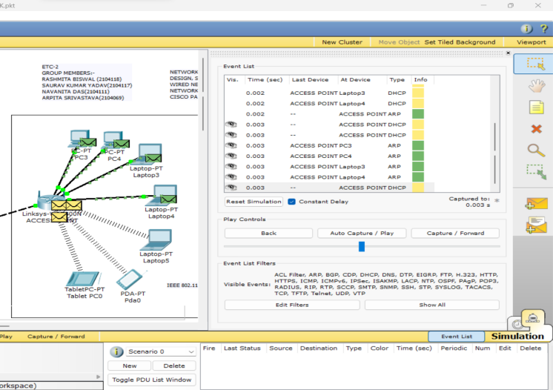

* ***PING Command***

***PC > Desktop > Command Prompt:***

***Ping 192.168.2.101***

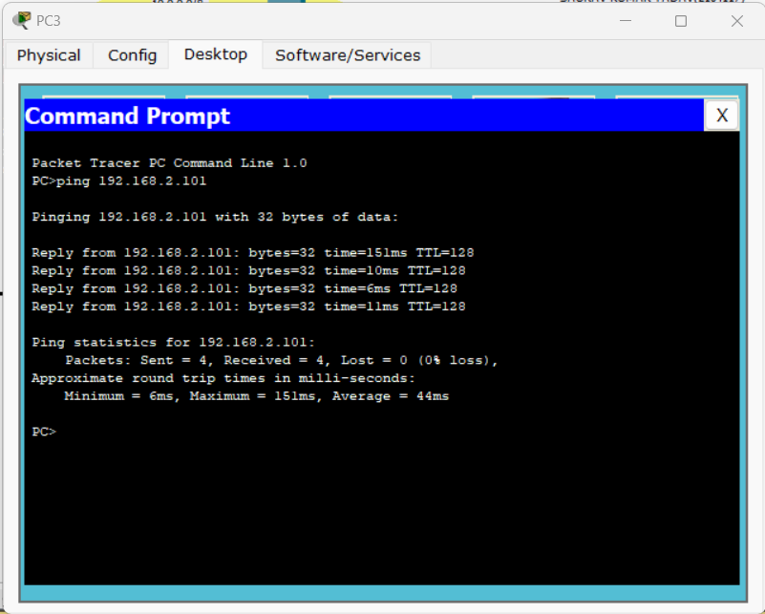

* ***HTTP over TCP Traffic in the Network in Simulation mode***

***PC > Desktop > Web Browser :***

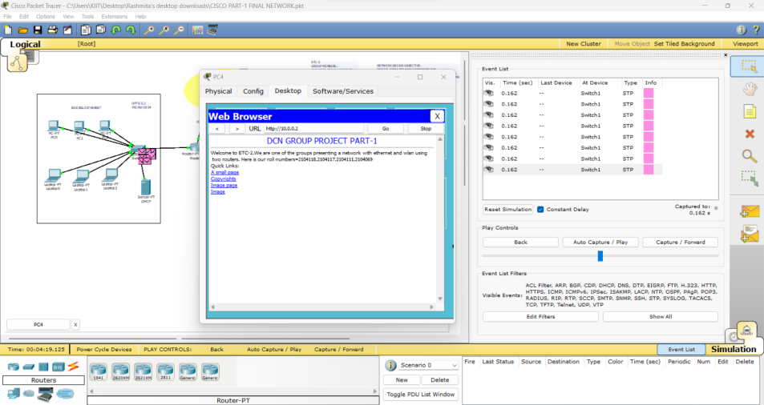

* ***Complex PDU***

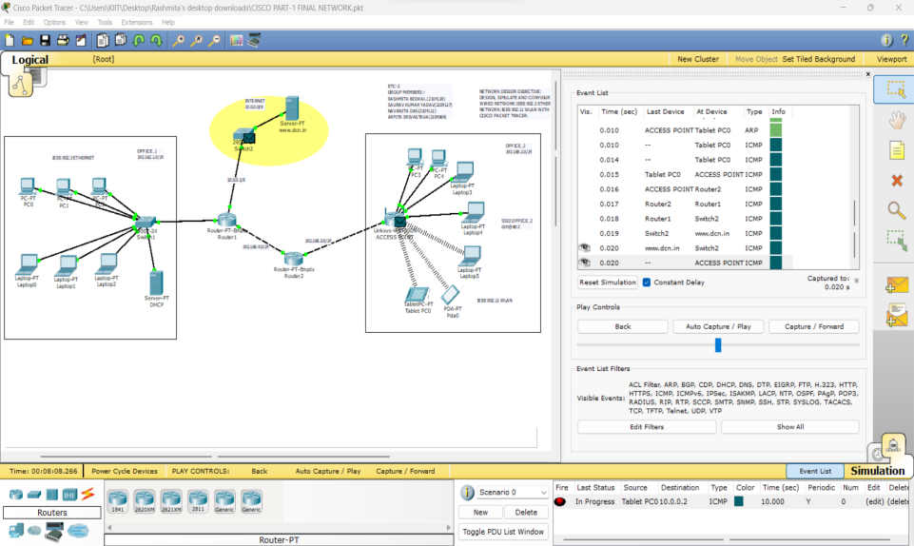

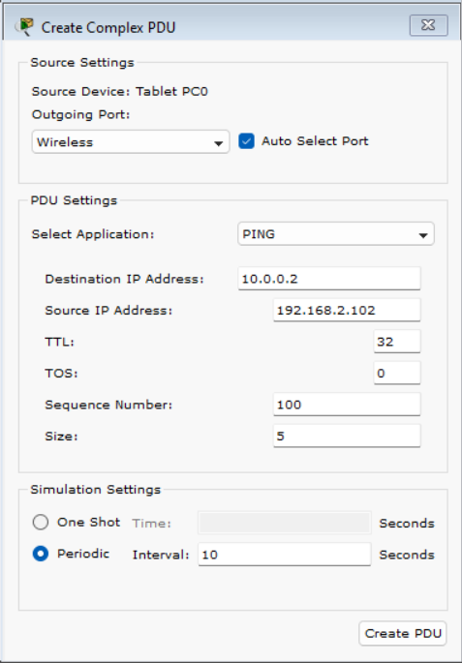

**\*\*\* END OF REPORT \*\*\***